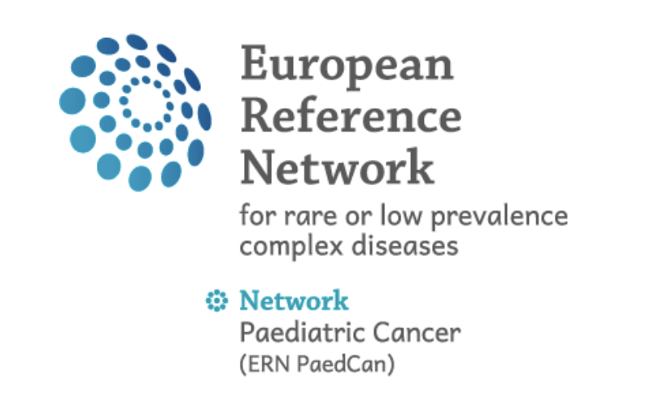

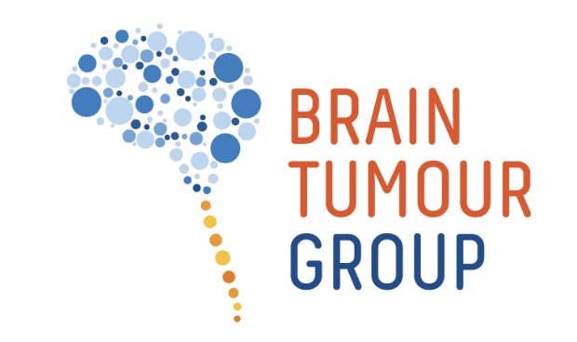

ERN / SIOP-E Rare Embryonal and Sarcomatous CNS Tumour REST - Tumour Board

Workflow in brief:

- Check if a consent is needed at your institution and get consent of the patient if required
- Register the patient with a standardised nickname including the acronym REST, the enrolment date and the institution as e.g.: “REST 20250507 Yourhospital 1”
- Add participants to the patient (select group: “Rare embryonal/sarcomatous brain tumours”)
- Add the clinical information in the .ppt template to be uploaded and presented in the meeting and insert a question to the tumour board in the CPMS discussion section.
- Upload the imaging data – latest Monday 14.00 CET/CEST before the meeting – each relevant DICOM series as ZIP file max 2 GB.
- Upload relevant pathology / molecular results as deidentified reports.

See further details below.

Detailed description

Aim
Rare embryonal and sarcomatous tumours of the CNS are rare diseases with no established standard of care. Given the rarity of the diseases, the lack of evidence and the often-poor prognosis, a REST-specific international tumour board is considered of high relevance for improving the treatment of current patients.
The patients will be discussed with a panel of experts in the field, with the aim to share and gain knowledge and to align recommendation in agreement with the recently published European Standard Clinical Practice Recommendations.

To allow future structured analyses and type specific research analyses, inclusion of patient in the SIOP-E CNS-REST Registry should be offered to all patients discussed in the SIOP-E REST Tumour Board.

ERN / SIOP-E CNS-REST Tumour Board Panel
Members of the ERN / SIOP-E CNS-REST Tumour Board Panel are listed below. Further experts may be additionally invited. The Panel may be adapted over time. Members of the Panel are expected to participate and support the meeting regularly.

Discipline |  | Name
Paed Oncology (coordinators) |  | Katja | von Hoff
 |  | Johannes | Gojo
 |  | Barry | Pizer
 |  | Sarita | Depani
 |  | Darren | Hargrave
 |  | Pascal | Johann
Molecular biology |  | Marcel | Kool
Neuropathology |  | Mariëtte | Kranendonk
 |  | David | Capper
 |  | Christine | Haberler
Neuropathology (pineal tumours) |  | Alexandre | Vasiljevic
on request |  | Martin | Hasselblatt
Neuroradiology |  | Anna | Tietze
 |  | Ulrike | Löbel
 |  | Maarten | Lequin
 |  | Kish | Mankad
Neurosurgery |  | Ulrich | Thomale
 |  | Eellco | Hoving
 |  | Oscar | Eelkman Rooda
Radiotherapy |  | Ajith | Ajithkumar
 |  | Yasmin | Lassen
 |  | John | Maduro
Genetics (Contact GENTURIS) on request |  | Karin | Wadt
Further members of the SIOP-E REST working group and guests may participate at the Tumour Board discussions.

Meeting times:
The ERN / SIOP-E CNS REST Tumour Board will be held every other
Wednesday from 14.00-15.00 CET/CEST (may be adapted)

Meeting platform:
The meeting will be held on the CPMS 2.0 platform: https://cpms2.ern-net.eu/screen/home
The Clinical Patient Management System (CPMS) is a secure and fully GDPR compliant IT platform aiming to facilitate the cross-border discussion of rare clinical cases.
The platform is supervised by the Directorate General for Health and Food Safety (DG SANTE) of the European Commission and funded under the EU4Health Programme.

The information to the ERN / SIOP-E CNS REST Tumour Board will be included on the platform of the ERN PaedCan: https://paedcan.ern-net.eu/e-health/

EU login account
To access the CPMS platform a EU login account is required. This can be created via the link: https://cpms2.ern-net.eu/screen/home.
When registering, you will need to configure a two-factor authentication.
When first accessing the platform a ”sign-up” step will be required. Please select ERN PaedCan as the respective responsible ERN.

Inclusion of a patient on an ERN / SIOP-E CNS REST Tumour Board meeting:
Inclusion may be requested by mail to the coordinating physicians (Katja von Hoff: katvon@rm.dk, Sarita Depani, or Johannes Gojo).

Workflow:
All information on the patient needs to be uploaded on CPMS2.0 until Monday 14.00 CET/CEST in a week where a meeting is held.
The following steps are needed from the requesting physician to upload the patient data:

- Check if a consent is needed at your institution and get consent of the patient
Consents for sharing medical data via CPMS for discussion of a patient case are available in all EU languages on the CPMS2.0 website: https://cpms2.ern-net.eu/screen/supporting-documents. Your hospital has a specific form or procedure to obtain consent from a patient for this system. If you are unaware of this internal procedure, please contact your hospital Data Protection Officer (DPO) and/or ERN specific representative.

Please note that there are different levels of consent:
- Primary consent (diagnosis and treatment)
- Secondary consent (education, export to registries)

When you discuss the CPMS with the patient / legal representative, please ask also for consent to educational purposes. This will allow to invite interested colleagues to follow the discussion.

- Register the patient under the tab “add new patient”.
Please assign a standardised nickname including the acronym REST, the enrolment date and the institution as e.g.: “REST 20250507 Yourhospital 1”.
Please insert this assigned name in the “Nickname” section and click on “validate”.

- Add participants to the patient (select group: “Rare embryonal/sarcomatous brain tumours”).

- Add the clinical information and question to the tumour board.
- Please summarize the patient information in a slide deck for presentation at the Tumour Board. (please use the slide deck template) Within the meeting it will be easiest, if you present this slide deck directly from your computer by screen sharing. Please upload the slide deck to the patient files before the meeting.
Please note that we have a discussion time of 15 min per patient. I.e. please keep the introduction short to 3 maximal 5 minutes.

- Klick on “open discussion” in the patient history. Please include an abbreviated summary including all relevant information and a precise question to the Tumour Board in the CPMS2.0 discussion section (“write discussion topic “).

- To get a more detailed and structured overview on the patient’s treatment course, we ask to summarize the patient clinical information also in the clinical information form and upload this as a separate file.

- Please upload imaging data.
- Please upload the DICOM data of all relevant MRI evaluations in the files section.
- Preoperative MRI
- Postoperative MRI
- Spinal MRI
- Further staging evaluations in case of suspicion or evidence of metastatic disease
- Further relevant follow-up MRI
- MRI in case/suspicion of relapse
- Relevant current MRI
Please be aware that each imaging needs to be uploaded in a separate file.
Please insert date of imaging acquisition (“investigation date”) at the upload. This is very important to match the images to the relevant clinical time point.
The process may require some time; therefore, we recommend starting upload with the most recent series and the respective most important baseline/comparison and initial imaging.
Please note: DICOM files musts be uploaded contained in zip-files. The size limit for a single zip file is 2GB. As many files as necessary can be uploaded.

In principle, DICOM data will be deidentified at the upload, but note that the responsibility for deidentification lies at the submitting institution.

- Please list the uploaded MRIs and the respective acquisition dates in the clinical information sheet (appendix.) This will facilitate the neuroradiology panel members to match the uploaded series to the clinical course of the patients.

- Please upload relevant pathology/molecular results.
Please upload all relevant reports on pathology/molecular results in the ”files” section of the CPMS. Please note that all uploaded files need to be de-identified.

